System Architecture

Team name
Project domain
Architecture chosen
Version | v1.0 — update when revised in response to feedback
This is a living document. Update the version number each time it is revised. The architecture documented here must remain consistent with the domain model (Portfolio Item 3) and the user story backlog (Portfolio Item 2).

Overview and Checklist
This portfolio item contains five sections developed across Weeks 4 and 5. Each section builds on the previous one and on the domain model produced in Portfolio Item 2.

✓ | Section |  | Content | Items | Connects to
□ | B | Item 4 | C4 context & container diagram | Diagram attachment + actor annotation table + container inventory table | Stakeholder map (Portfolio Item 1),  Bounded contexts (Portfolio Item 3)
□ | C |  | C4 component diagram | Diagram attachment + module interface table + cross-module communication summary | Bounded contexts + cross-boundary refs (Portfolio Item 3)
□ | D |  | Integration pattern summary | One row per significant integration | To-be BPMN (Portfolio Item 4); OpenAPI spec (Week 4)
□ | E | Item 5 | Two ADRs | ADR-01 integration, ADR-02 consistency | All portfolio items; user story IDs from Portfolio Item 1

Consistency check, run before submitting.
Every module or service in the C4 container and component diagrams must correspond to a bounded context in your domain model. Every cross-boundary reference annotated in the domain model worksheet must appear as an inter-module communication path in the component diagram. Every integration pattern in Section D must be documented in ADR-02 or have a reference to the ADR that covers it. If any of these checks fail, review your domain model and architecture together before submitting.

Context and Container diagram
Attach or embed your C4 Level 2 diagram below. Your system scope boundary (i.e., level 1 Context diagram) has to be correctly shown as part of your level 2 (Container) diagram. The context diagram shows the system as a single box, the people who interact with it, and the external systems it depends on or integrates with. It does not show internal structure.
The Container diagram shows the high-level technical building blocks (containers) and how they communicate. A container is anything that runs or stores data: a web application, a database, a message queue. Produce the diagram in draw.io. Use the correct shapes under C4 tab as discussed in class.

C4 context diagram minimum requirements.
The system shown as one named box with a brief description. All human actors from the Week 1 stakeholder map that interact with the system directly (not just affected by it). All external software systems the system calls or receives calls from (payment provider, governing body registration system if applicable). Arrows labelled with the nature of the interaction (e.g. 'renews membership online', 'processes payment via API'). Consistent C4 notation: Person shapes for people, System shapes for software systems.

The container diagram changes depending on your architecture choice.
Monolith: one web application container and one database container. Modular monolith: one web application container (with an internal note listing the modules) and one database container (with schema separation noted). Microservices: one container per service, each with its own database container; communication paths labelled with mechanism (REST, event bus, etc.). All variants: include the technology choice for each container (e.g. 'PostgreSQL database', 'Node.js web application').

Actor and external system annotation
Complete one row per actor or external system shown in the context diagram. Every element in the diagram must appear in this table. The stakeholder column links this diagram back to the Week 1 stakeholder map. (do not include stakeholders that are not in your diagram)

Name in diagram | Type | Stakeholder map reference | Interaction with system
Student | Person / External system | Low power, High interest | Browses active listings, views item details, filters by location, saves bookmarks, receives push notifications when new items are posted
Org Rep/Staff | Person / External system | Low power, High Interest | Creates and submits free item giveaway listings, edits and removes own active listings, receives approval or rejection notifications from admin
System Admin | Person / External system | High power, low interest | Reviews and approves or rejects pending listings, removes fake or policy-violating posts, monitors platform activity, generates engagement reports
Push Notification Service | Person / External system | Technical dependency | Receives notification delivery requests from the web application and delivers push alerts to student devices via API
 | Person / External system

Container inventory and architecture justification
List every container in the diagram and justify the architectural choice in the box below.

Container name | Type | Technology (optional) | Responsibility
Web Application | Web app / Database / Queue / Service | Node.js/Express | Serves the REST API for all six bounded contexts. Contains six internal modules: Identity, Organization, Listing, Saved, Notification, Governance. Hosts the internal event bus and notification
PostgreSQL Database | Web app / Database / Queue / Service | PostgreSQL | Single shared database with six schema namespaces: identity., organization., listing., saved., notification., governance.. Each module has exclusive write access to its own schema.
Push Notification system | Web app / Database / Queue / Service | Firebase Cloud Messaging | Receives push notification requests from the Notification module and delivers alerts to student devices. The web application calls the FCM API
 | Web app / Database / Queue / Service

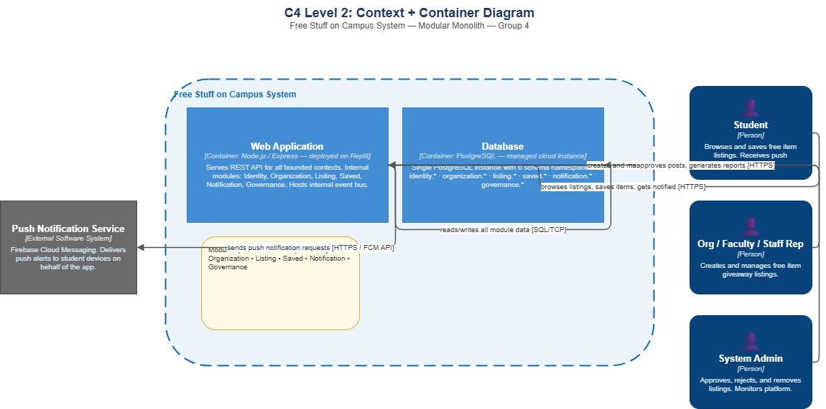

Component diagram
Attach or embed your C4 Level 3 component diagram for the primary container (the web application). This diagram shows the internal components (modules or services) and how they communicate with each other. For a modular monolith, this is the primary deliverable: it makes the bounded context structure and interface discipline visible.

Component diagram minimum requirements.
Each bounded context from the domain model appears as a named component with a type label [Module] or [Service]. Every inter-module or inter-service communication path is shown with an arrow labelled with:
- the nature of the call (e.g. 'get subscription status'),
- the mechanism (synchronous function/method call, async internal event, REST call, message queue). An internal event bus component is shown if used.
- The database is shown with schema separation annotated (e.g. membership.* schema, bookings.* schema).
- External systems that a module calls directly (e.g. payment provider) are shown as external components.

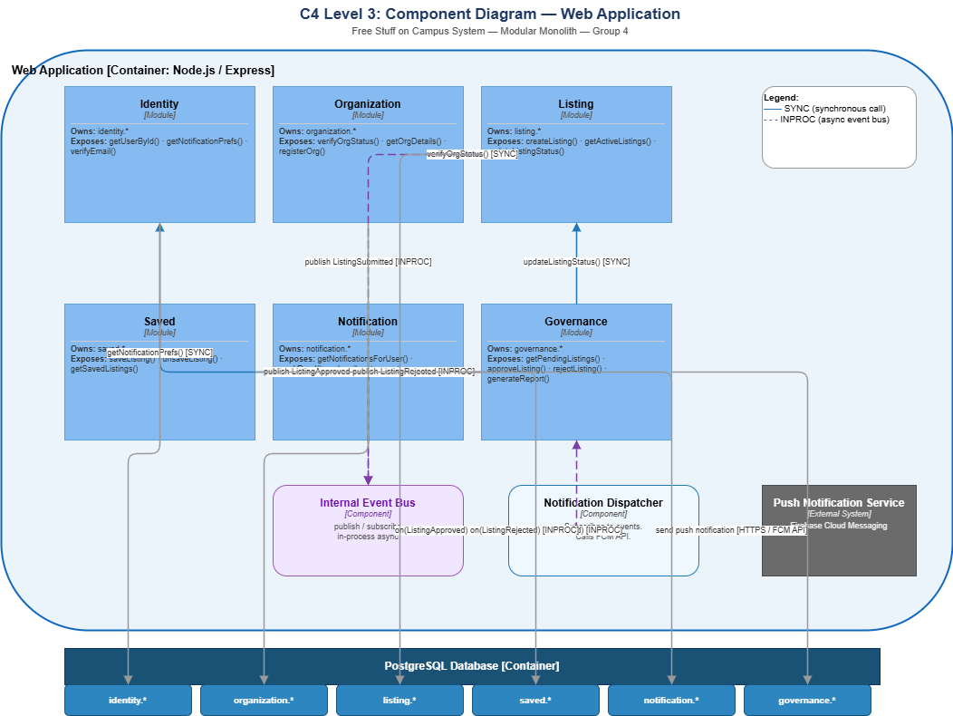

Module interface table
Complete one row per module or service shown in the component diagram. For each module, document the interface it exposes to other modules. The interface should describe what a module offers to other modules the named operations (e.g. getSubscriptionStatus, confirmBooking) and what they return. It should not describe internal database queries, internal functions, or implementation details. If the modular monolith is ever extracted to microservices, this interface becomes the API contract.

Module / service | Owns (data) | Interface operations exposed | Called by
Identity | identity.* (User entity) | getUserById(userId) → {userId, email, firstName, lastName, role} · getNotificationPrefs(userId) → {channel, categories, locations} · verifyEmail(token) → boolean | Notification (getNotificationPrefs), Governance (getUserById), client-facing API
Organization | organization.* (StudentOrg, OrgMembership entities) | verifyOrgStatus(orgId) → {status: PENDING|VERIFIED|REJECTED} · getOrgDetails(orgId) → {orgId, orgName, orgType, contactEmail} · registerOrg(request) → orgId | Listing (verifyOrgStatus before accepting a post), client-facing API
Listing | listing.* (Listing, Category, Location entities) | createListing(request) → listingId · getActiveListings(filters?) → Listing[] · getListingById(listingId) → Listing · updateListingStatus(listingId, status, reason?) → void · getListingsByOrg(orgId) → Listing[] | Governance (updateListingStatus on approval/rejection), client-facing API
Saved | saved.* (SavedListing entity) | saveListing(userId, listingId) → void · unsaveListing(userId, listingId) → void · getSavedListings(userId) → Listing[] | Client facing API only
Notification | notification.* (Notification entity) | getNotificationsForUser(userId) → Notification[] · markRead(notificationId) → void · Subscribes to: on(ListingApproved) → dispatch push to matching students · on(ListingRejected) → notify org rep | Client facing API, called by internal event
Governance | governance.* (ModerationAction entity) | getPendingListings() → Listing[] · approveListing(listingId, adminId) → void · rejectListing(listingId, adminId, reason) → void · removeListing(listingId, adminId, reason) → void · getModerationHistory(listingId) → ModerationAction[] · generateReport(params) → Report · Subscribes to: on(ListingSubmitted) → create pending ModerationAction | Admin client facing API; called by internal event

Cross-module communication summary
Complete one row per inter-module or inter-service communication path shown in the component diagram. This table must correspond exactly to the arrows on the diagram and to the cross-boundary references annotated in the annotated domain model (Portfolio Item 3).

Caller | Callee | Operation / event | Justification for this communication path
Listing | Organization | verifyOrgStatus(orgId) [synchronous] | Before accepting a listing submission, the Listing module must confirm the org is VERIFIED. The caller needs an immediate yes/no answer to proceed. if unverified, the submission is rejected before it enters the system. Cannot be deferred.
Governance | Listing | updateListingStatus(listingId, status, reason) [synchronous] | When an admin approves or rejects a listing, the Listing module must update the status atomically. The admin's screen must show immediate confirmation of the action, so the call must be synchronous.
Notification | Identity | getNotificationPrefs(userId) [synchronous] | Before dispatching a push alert, the Notification module needs the student's channel preferences and category filters. The caller needs these immediately to decide whether and how to send the notification.
Listing | Internal Event bus | publish ListingSubmitted [asynchronous — INPROC] | When a listing is submitted, Governance needs to create a pending moderation entry. This does not need to complete before the org rep receives their submission confirmation. Async decouples posting speed from moderation queue creation.
Governance | Internal Event bus | publish ListingApproved [asynchronous — INPROC] | When a listing is approved, the admin's confirmation should return immediately without waiting for notifications to be dispatched to potentially hundreds of students. Multiple modules can subscribe to this event independently.
Governance | Internal Event bus | publish ListingRejected [asynchronous — INPROC] | Rejection notification to the org rep does not need to complete before the admin sees their action confirmed. Keeps the admin's response time independent of notification delivery.
Internal Event Bus | Notification Dispatcher | on(ListingApproved | ListingRejected) [asynchronous — INPROC] | The Notification Dispatcher subscribes to approval and rejection events and routes them to the appropriate recipients. students for approvals, org reps for rejections. Decouples notification logic from moderation logic.

Integration pattern summary
Complete one row per significant integration in your system; both internal (module to module) and external (module to external system). All patterns must be one of the five covered in the Week 6 lecture. The pattern column must match what is shown in the component diagram (Section C). ADR-01 must justify the pattern chosen for at least the two most significant integrations.

Pattern | Abbreviation | Use when
Synchronous request-reply | SYNC | The caller needs an immediate answer to proceed. Fast, simple, creates temporal coupling.
Async message queue | QUEUE | The result is not needed immediately. Producer and consumer decouple in time. One consumer.
Event stream | STREAM | Multiple independent consumers need the same event. Replay required. Durable audit trail needed.
Webhook | WEBHOOK | An external system pushes notifications to your system on events it generates.
In-process event bus | INPROC | Modular monolith only. Async decoupling within a single process. Lighter than a message queue.

Integration pattern rationale.
The rationale should answer the three Week 6 decision questions:
- Does the caller need an immediate response?
- Does one consumer handle this or do multiple consumers react independently?
- Is this communication with an external system that pushes notifications?
A rationale that states only 'we chose X because it is simpler' has not applied the decision framework.

# | From (module/service) | To (module/service) | Pattern | Rationale; why this pattern for this integration?
1 | Listing | Organization | Select: Synchronous request-reply / Async message queue / Event stream / Webhook / In-process event bus | Does the caller need an immediate response? Yes: if the org is not verified, the listing must be rejected before it is saved. Can this be deferred?  No: the poster is waiting for confirmation. One consumer? Yes.  Pattern: SYNC.
2 | Governance | Listing | Select: Synchronous request-reply / Async message queue / Event stream / Webhook / In-process event bus | Does the caller need an immediate response?  Yes: the admin must see the listing status updated before their approval action completes. Can this be deferred?  No: immediate consistency required. One consumer? Yes. Pattern: SYNC.
3 | Notification | Identity | Select: Synchronous request-reply / Async message queue / Event stream / Webhook / In-process event bus | Does the caller need an immediate response?  Yes: notification preferences must be fetched before the dispatch decision is made. Can this be deferred?  No: the dispatcher cannot send without knowing the student's channel choice. One consumer? Yes. Pattern: SYNC.
4 | Listing | Internal Event Bus | Select: Synchronous request-reply / Async message queue / Event stream / Webhook / In-process event bus | Does the caller need an immediate response?  No: listing submission confirmation does not depend on the moderation queue being created. Multiple consumers? Governance subscribes; analytics could subscribe in future. Same process? Yes: modular monolith. Pattern: INPROC.
5 | Governance | Internal Event Bus | Select: Synchronous request-reply / Async message queue / Event stream / Webhook / In-process event bus | Does the caller need an immediate response?  No: admin approval confirmation does not depend on notifications being sent to students. Multiple consumers?  Yes: Notification subscribes, and future analytics could also subscribe. Same process? Yes. Pattern: INPROC.
6 | Governance | Internal Event Bus | Select: Synchronous request-reply / Async message queue / Event stream / Webhook / In-process event bus | Does the caller need an immediate response?  No: rejection notification to org does not block the admin's action confirmation. Same process?  Yes. Multiple consumers? Notification subscribes. Pattern: INPROC.
7 | Internal Event Bus | Notification Dispatcher | Select: Synchronous request-reply / Async message queue / Event stream / Webhook / In-process event bus | Does the caller need an immediate response?  No: event dispatch is fire-and-forget within the same process. Multiple consumers?  The dispatcher is the single subscriber but handles both approval and rejection event types. Same process? Yes. Pattern: INPROC.
8 | Notification Dispatcher | Push Notification Service | Select: Synchronous request-reply / Async message queue / Event stream / Webhook / In-process event bus | Is this communication with an external system that pushes notifications to your system?  No: in this case our system calls out. The external system (FCM) receives our request and delivers to student devices.  Does the caller need an immediate delivery confirmation?  No: delivery is best-effort. Pattern: WEBHOOK (outbound call to external push API).

Architecture Decision Records (ADR)
Two Architecture Decision Records are required. Each captures a significant, hard-to-reverse decision. Complete all fields. The consequences section is the most analytically important part of an ADR, and the most commonly underdeveloped. Positive consequences that list only benefits and negative consequences that list 'none' are not honest. Every architectural decision makes something harder. Name it. An ADR that cannot identify any negative consequences has not been thought through seriously.
Empty consequences sections or alternatives without rejection reasoning will not receive credit.

ADR | Decision area | Guidance
ADR-01 | Primary integration pattern | Choose the integration pattern for the most significant inter-module or inter-service communication in your system. Apply the three decision questions. Alternatives must include at least synchronous and asynchronous options. Reference the specific integration (e.g. 'booking confirmation to notification module').
ADR-02 | Data consistency approach | Document how data consistency across module or service boundaries is maintained. For a modular monolith: how schema separation is enforced and when cross-schema transactions are permitted. For microservices: acknowledge eventual consistency, name the operations most at risk, and specify which pattern (saga, outbox, or compensating approach) would be used. Alternatives must include at least one distributed approach and one simpler approach.

ADR-1: Primary integration pattern

ADR-1: Use async in process event bus for listing approval to student notification
Title | Use asynchronous in-process event bus for Governance-to-Notification integration
Status | Proposed Accepted Superseded choose one
Context | Describe the situation: When the system admin approves a listing, the system must both provide an on-screen confirmation to the admin, as well as dispatch push notifications to potentially hundreds of students. The approval of a listing by the admin is the only requirement of US-06; it must respond immediately to the admin’s action. The Notification module will be responsible for dispatching the push notifications; the Governance module will be responsible for the admin’s approval of a listing. These two modules must be decoupled from each other. The system will exist as a modular monolith on Replit, with no external message broker infrastructure available.
Decision | For the integration between Governance and Notification, we will use an asynchronous in-process event bus. When a listing is approved in the Governance module, an event is published on the event bus. The Notification module is subscribed to this event and dispatches push notifications asynchronously. The admin will receive confirmation of the listing approval without waiting for the student notifications to be processed.
Alternatives considered | Complete one row per alternative. At least two alternatives are required.
Alt. 1 | Option: Synchronous call from Governance directly to Notification.  Rejected because: This would make the admin’s response time dependant upon dispatching notifications to potentially hundreds of students, which could take several seconds. Furthermore, if the notifications system failed, the approval would also fail.
Alt. 2 | Option: External message queue (Redis or RabbitMQ)  Rejected because: The added complexity of deploying and maintaining an external message broker is not justified by the current project size and team. The same functionality can be achieved in-process.
Alt. 3 | Option: Write directly to the database's notifications queue table from the Governance module.  Rejected because: due to the Governance module having to know the schema structure of the Notification module; a violation of the boundary of the module and its dependencies not being represented on the component diagram.
Positive consequences | 1. A failure in the notification dispatch does not cause the approval action to fail  2. Admin approval response time is not affected by notification delivery time  …
Negative consequences | 1. If the process crashes between event publication and subscriber processing, events may be lost, an in-process event bus has no durability guarantees of an external message broker  2. If notification dispatch fails midway (after sending to some but not all students), there is no automatic retry  …
Traces to | US-05, US-06, US-04

ADR-2: Data consistency approach

ADR-2: Manage data consistency across boundaries using schema separation with local transactions
Title | Manage data consistency using schema separation
Status | Proposed Accepted Superseded choose one
Context | Describe the situation: The modular monolith uses a single PostgreSQL database and breaks its tables into six schema namespaces. The requirements for data consistency include that: (1) no listing can be accepted from an unverified organization; (2) moderation actions must always be associated with both a listing and an admin; and (3) listing status changes and moderation actions must either both succeed or both fail. All of this takes place on a single instance of PostgreSQL which supports ACID transactions. Due to the lack of experience with distributed systems, and the fact that the current scope of the project is limited to a single campus, there is no need for distributed database systems.
Decision | We will use this because each module will have its own exclusive “ownership” and none of them will have the ability to write in another modules schema
Alternatives considered | Complete one row per alternative. At least two alternatives are required.
Alt. 1 | Option: Eventual consistency with the saga pattern  Rejected because: the saga pattern is for distributed systems where a transaction cannot span multiple databases. Since all modules of the monolith share the same PostgreSQL database, ACID transactions can ensure consistency.
Alt. 2 | Option: Outbox pattern for all cross-module operations  Rejected because: outbox pattern guarantees that the event will be published if and only if the database write succeeded within the same local transaction.
Alt. 3 | Option:  Rejected because:
Positive consequences | 1. PostgreSQL ACID transactions provide strong consistency guarantees across all schemas  2. Local transactions are simpler to implement, test, and debug than saga or outbox patterns  …
Negative consequences | 1. If the system is ever extracted to microservices, this consistency approach cannot cross service boundaries  2. A single database is a single point of failure. all six modules are affected simultaneously if the database becomes unavailable
Traces to | US-02, US-06

Assessment Rubric
Sections B and C (including the C4 diagrams) are collectively weighted at 10% of the overall course. Section C (the ADRs) are collectively weighted at 6% of the overall course.

Criterion | Description | Distinction | Credit | Pass / Rework
C4 context diagram | System boundary correctly drawn. All external actors from the stakeholder map represented. External systems (payment provider, governing body) included. Notation consistent with C4 conventions. | All actors present and correctly typed. External systems named with communication mechanism annotated. Fully consistent with stakeholder map. | All actors present. Minor external system omissions. Notation mostly correct. | Key actors missing. External systems absent. Notation inconsistent or incorrect.
C4 container diagram | Architecture choice clearly reflected. Containers correctly identified for the chosen pattern. Communication paths labelled with mechanism. Database containers present with ownership noted. | Container diagram precisely reflects the chosen architectural pattern. All inter-container communication paths labelled. Database structure reflects domain model. | Correct pattern reflected. Most communication paths present. Minor labelling gaps. | Architecture not clearly reflected. Containers generic or incorrect. Communication paths unlabelled.
C4 component diagram | Internal module structure shown for the primary container. Each bounded context is a named component. Module interfaces labelled. Cross-module communication paths show mechanism (sync/async). Corresponds to (annotated ERD) domain model bounded contexts. | All bounded contexts present as named components with interface descriptions. Every cross-module communication path labelled with mechanism. Direct correspondence to annotated ERD domain model. | Most bounded contexts present. Some interfaces labelled. Cross-module paths mostly shown. | Components generic or missing. No interface labelling. No correspondence to domain model.
Integration pattern summary | All significant inter-module or inter-service integrations listed. Pattern selected for each with explicit rationale referencing the Week 6 decision framework. At least one asynchronous pattern present. Patterns consistent with component diagram. | All significant integrations listed. Pattern selection justified with the three decision questions. Patterns match component diagram. | Most integrations listed. Patterns selected but rationale brief. Minor inconsistencies with component diagram. | Integrations missing or incomplete. Patterns selected without rationale. Inconsistent with component diagram.
ADR quality | Each ADR has a clear decision statement, at least two alternatives considered with explicit rejection reasoning, and separate lists of positive and negative consequences. ADR-1 integration pattern, ADR-2 data consistency. All trace to user stories or portfolio items. | Both ADRs complete with defensible alternatives and honest consequences. Negative consequences explicitly named. Each ADR traceable to specific user stories. | Both ADRs present. Most alternatives have rejection reasoning. Consequences present but may be one-sided. | Less than two ADRs. Alternatives listed without rejection reasoning. Consequences absent or only positive.

Connection to Week 7
The component diagram in Section C is the primary input to the Week 7 security and privacy review. Each module interface is a potential attack surface. The Safeguarding module interface, which exposes junior member records, has fundamentally different access control requirements from the Bookings module interface. Before starting the OWASP review, review your component diagram and identify which module interfaces handle sensitive or restricted data; those are the highest-priority items for the security checklist.

Revision Log
Version | Date | Revised by | What changed and why
v1.0 |  |  | Initial submission

